**Iowa Alliance for Arts Education**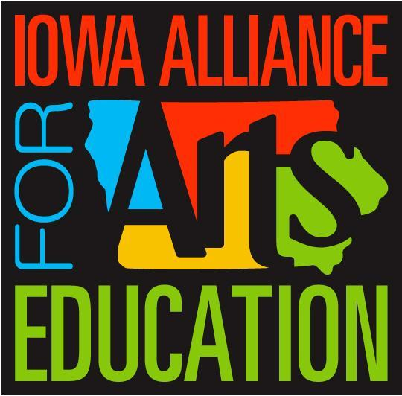

*“Advancing the He****art*** *of 21st Century Education”*

Learn more about the Model of Excellence Mentor Program at [iowaalliance4artsed.org](https://iowaalliance4artsed.org/) or email [iaae.mentor@gmail.com](mailto:iaae.mentor@gmail.com).

Mentor Committee Contact Info

**Mentor Program Administrators IAAE Board Representative**

Leon Kuehner [leongkuehner@gmail.com](mailto:leongkuehner@gmail.com) Jennifer Gaesser

Cassidy Noring [iaae.mentor@gmail.com](mailto:iaae.mentor@gmail.com) [jegaes01@gmail.com](mailto:jegaes01@gmail.com)

**Art Educators of Iowa**

Advocacy Chair

Maddie Maddock

[mentoring@artedia.org](mailto:mentoring@artedia.org)

**Iowa Bandmasters Association**

IBARD Chair Mentor Coordinator Mentor Chair

Terry Hanzlik Ted Schacherer Russ Kramer

[ibard@bandmasters.org](mailto:ibard@bandmasters.org) [tschacherer@nfv.k12.ia.us](mailto:tschacherer@nfv.k12.ia.us) [rkramer@masoncityschools.org](mailto:rkramer@masoncityschools.org)

**Iowa Choral Directors Association**

Mentor Co-Chair Mentor Co-Chair

Julie Schnieders Nick Oswald

[schniedersvoice@gmail.com](mailto:schniedersvoice@gmail.com)  [nick.oswald@ankenyschools.org](mailto:nick.oswald@ankenyschools.org)

**Iowa Music Educators Association**

Mentor Co-Chair Mentor Co-Chair

Michelle Swanson Nicole Ramsey

[michelle.swanson@uni.edu](mailto:michelle.swanson@uni.edu) [nicole.ramsey@drake.edu](mailto:nicole.ramsey@drake.edu)

**Iowa String Teachers Association**

Mentor Chair

Tabitha Rasmussen

[trasmussen@mvcsd.org](mailto:trasmussen@mvcsd.org)

**Iowa Thespians Association Iowa High School Speech Association**

Mentor Chair Mentor Chair- Stacy Hansen

Helen Duranleau-Brennan stacy@ihssa.org

[helendbrennan@gmail.com](mailto:helendbrennan@gmail.com)